**Module 2: Lab 1, Java Script**

Sushmita Prafull Halasawade

IFT 544: Middleware Prog & Database Sec

Dinesh Sthapit

3 Sep 2023

**Part A: creating http server:**

createServer(): Returns a new instance of Server.

Server.listen() : Start a server listening for connections.

url: The node:url module provides utilities for URL resolution and parsing

url.parse(): The url.parse() method takes a URL string, parses it, and returns a URL object.

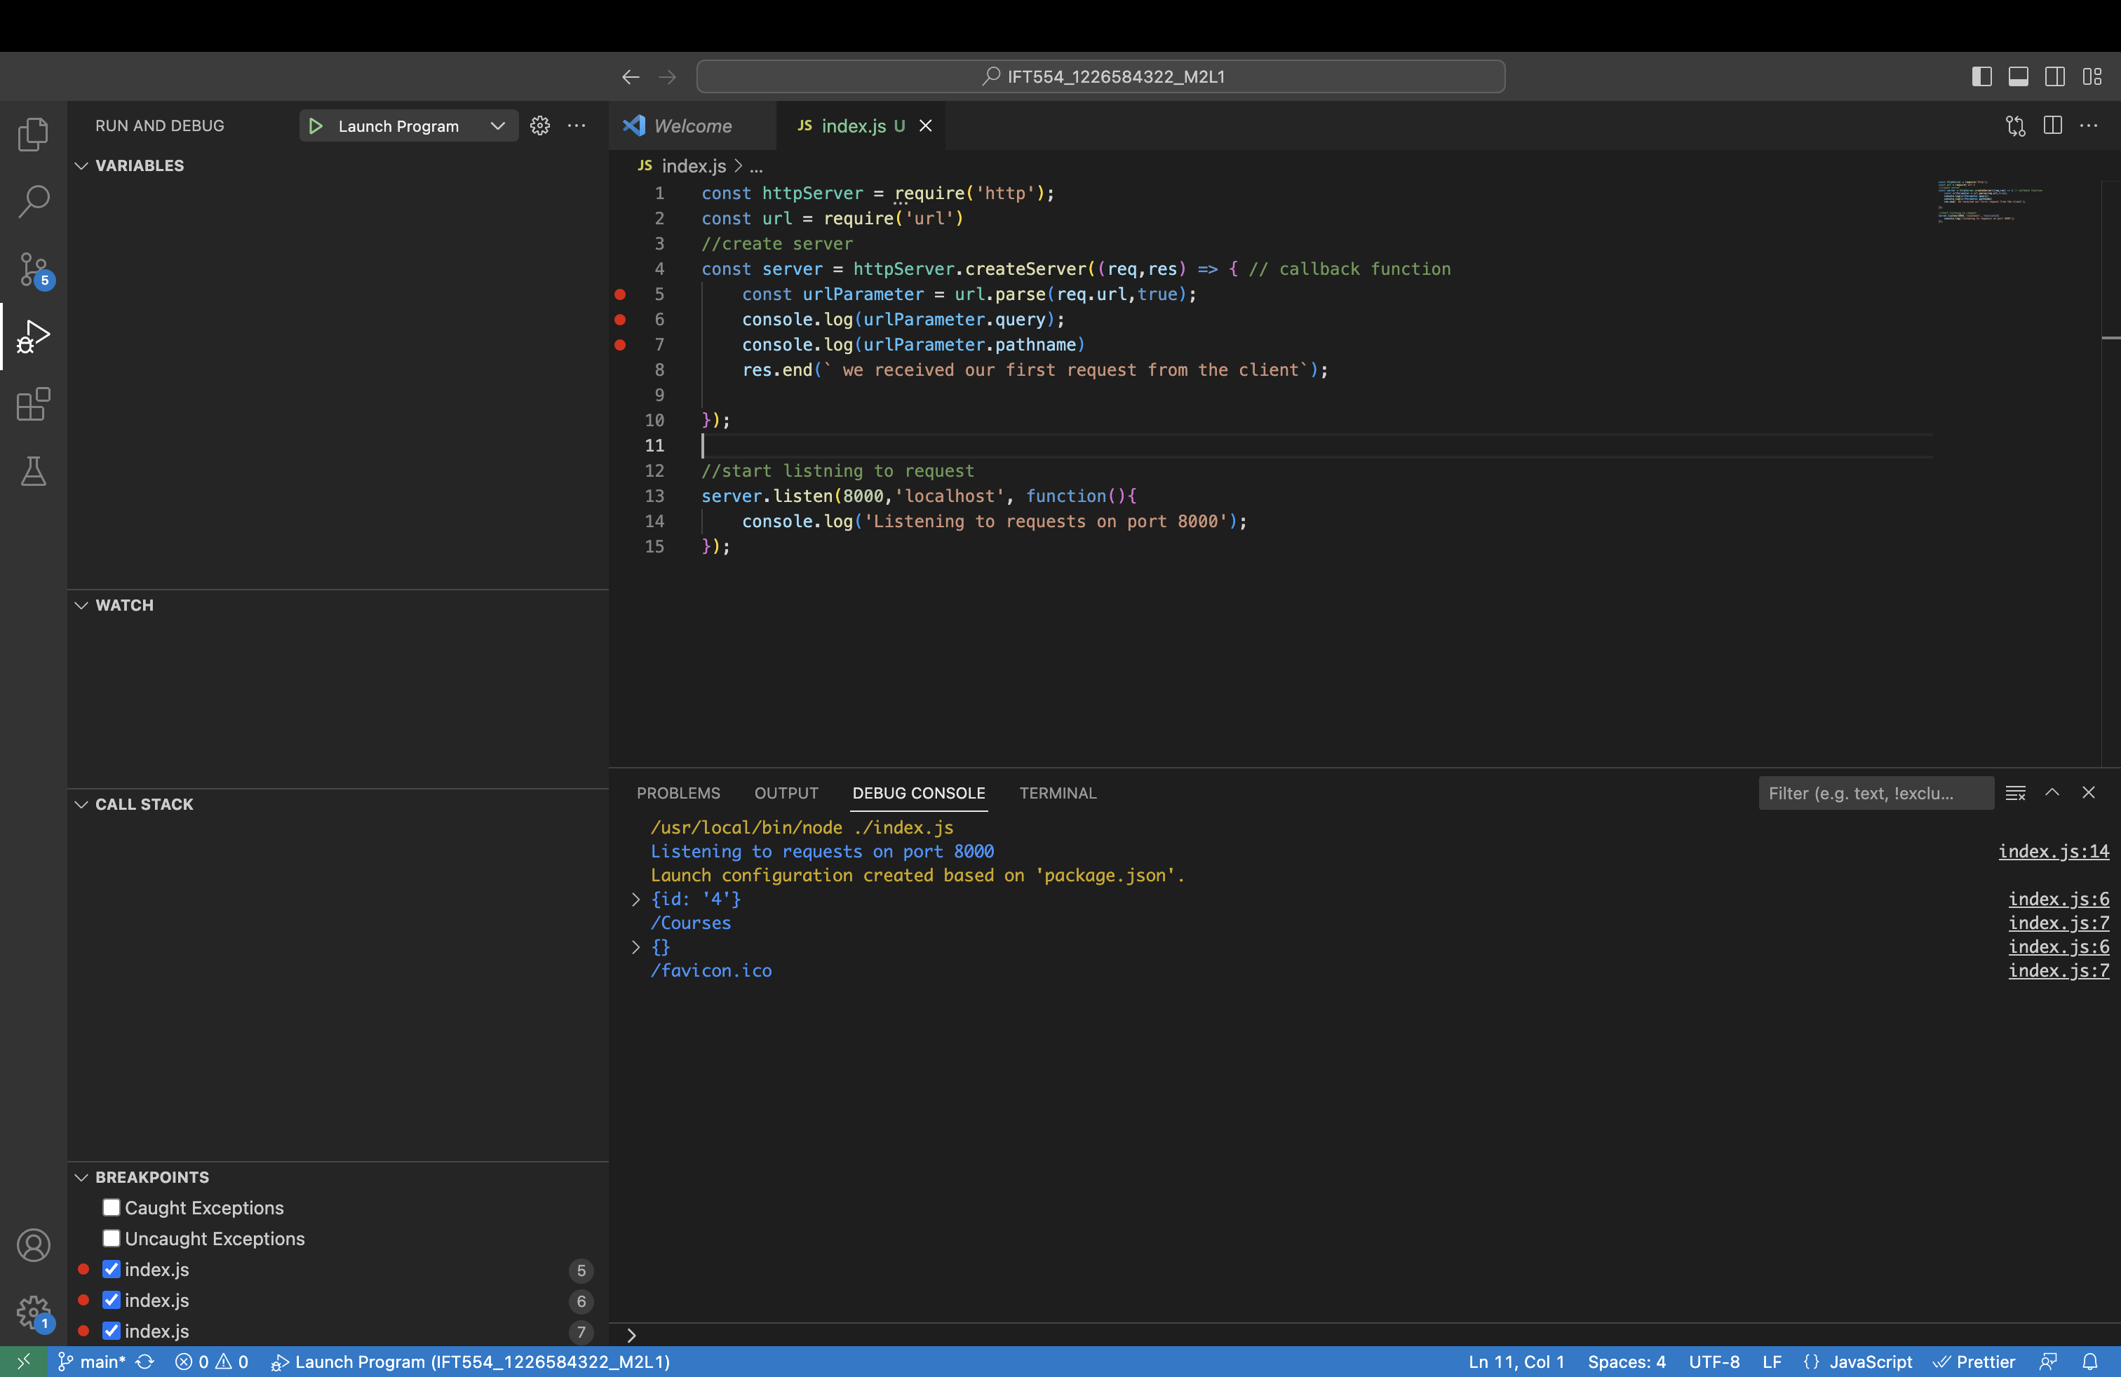

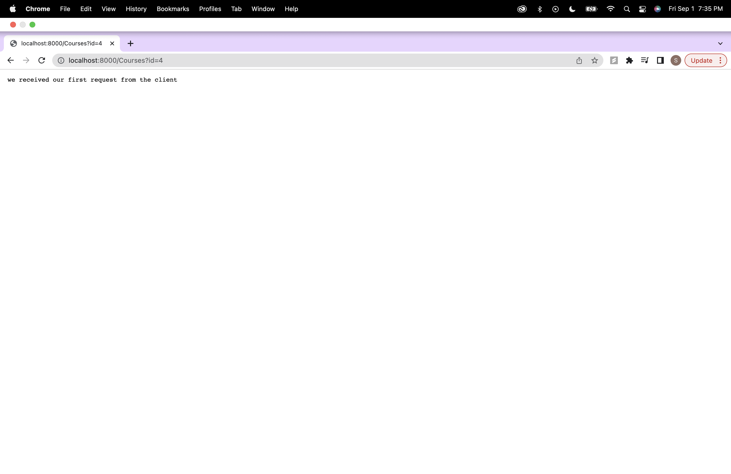

**Part B: Setting response headers:**

writeHead(): Sends a response header to the request.

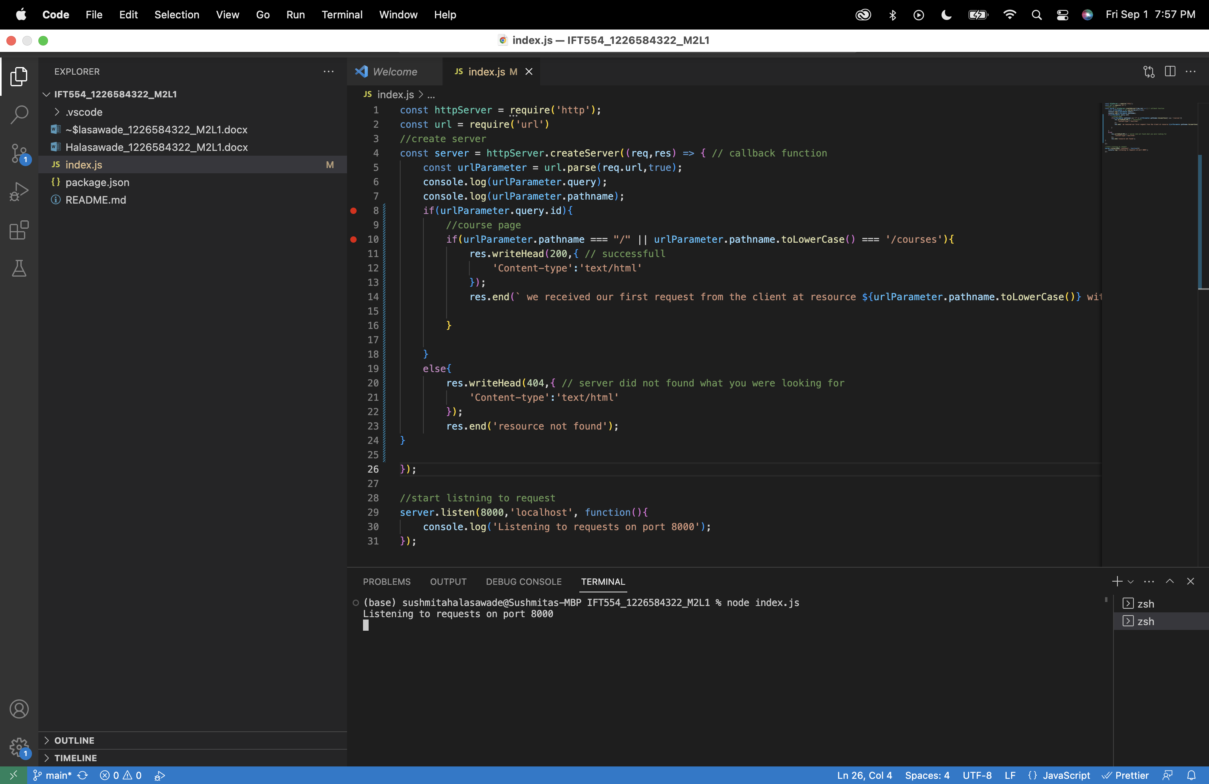

With id parameter: (<http://localhost:8000/Courses?id=5>) status code should be 200

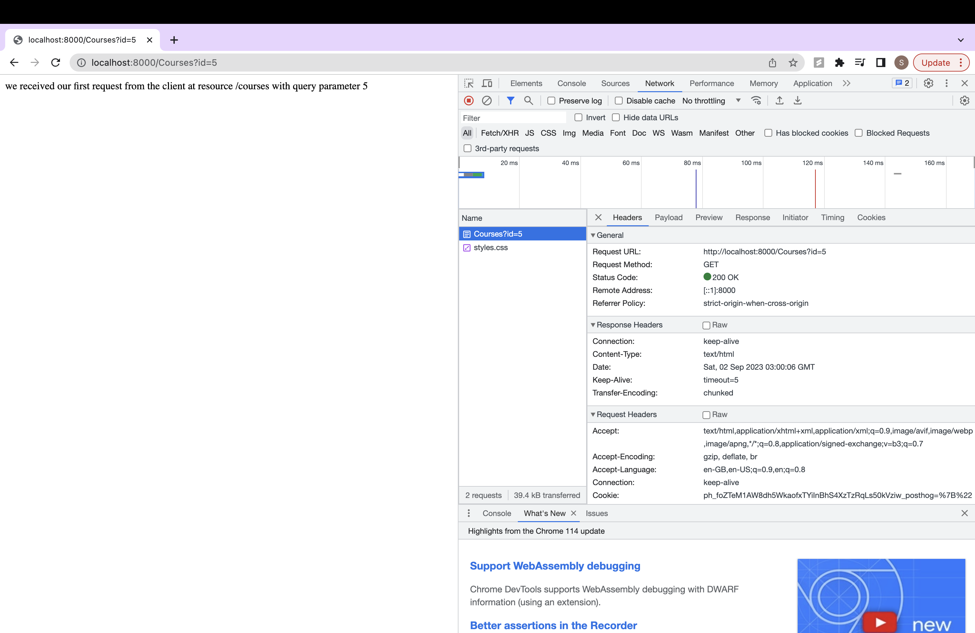

Without id parameter: (<http://localhost:8000/Courses>) status code should be 404

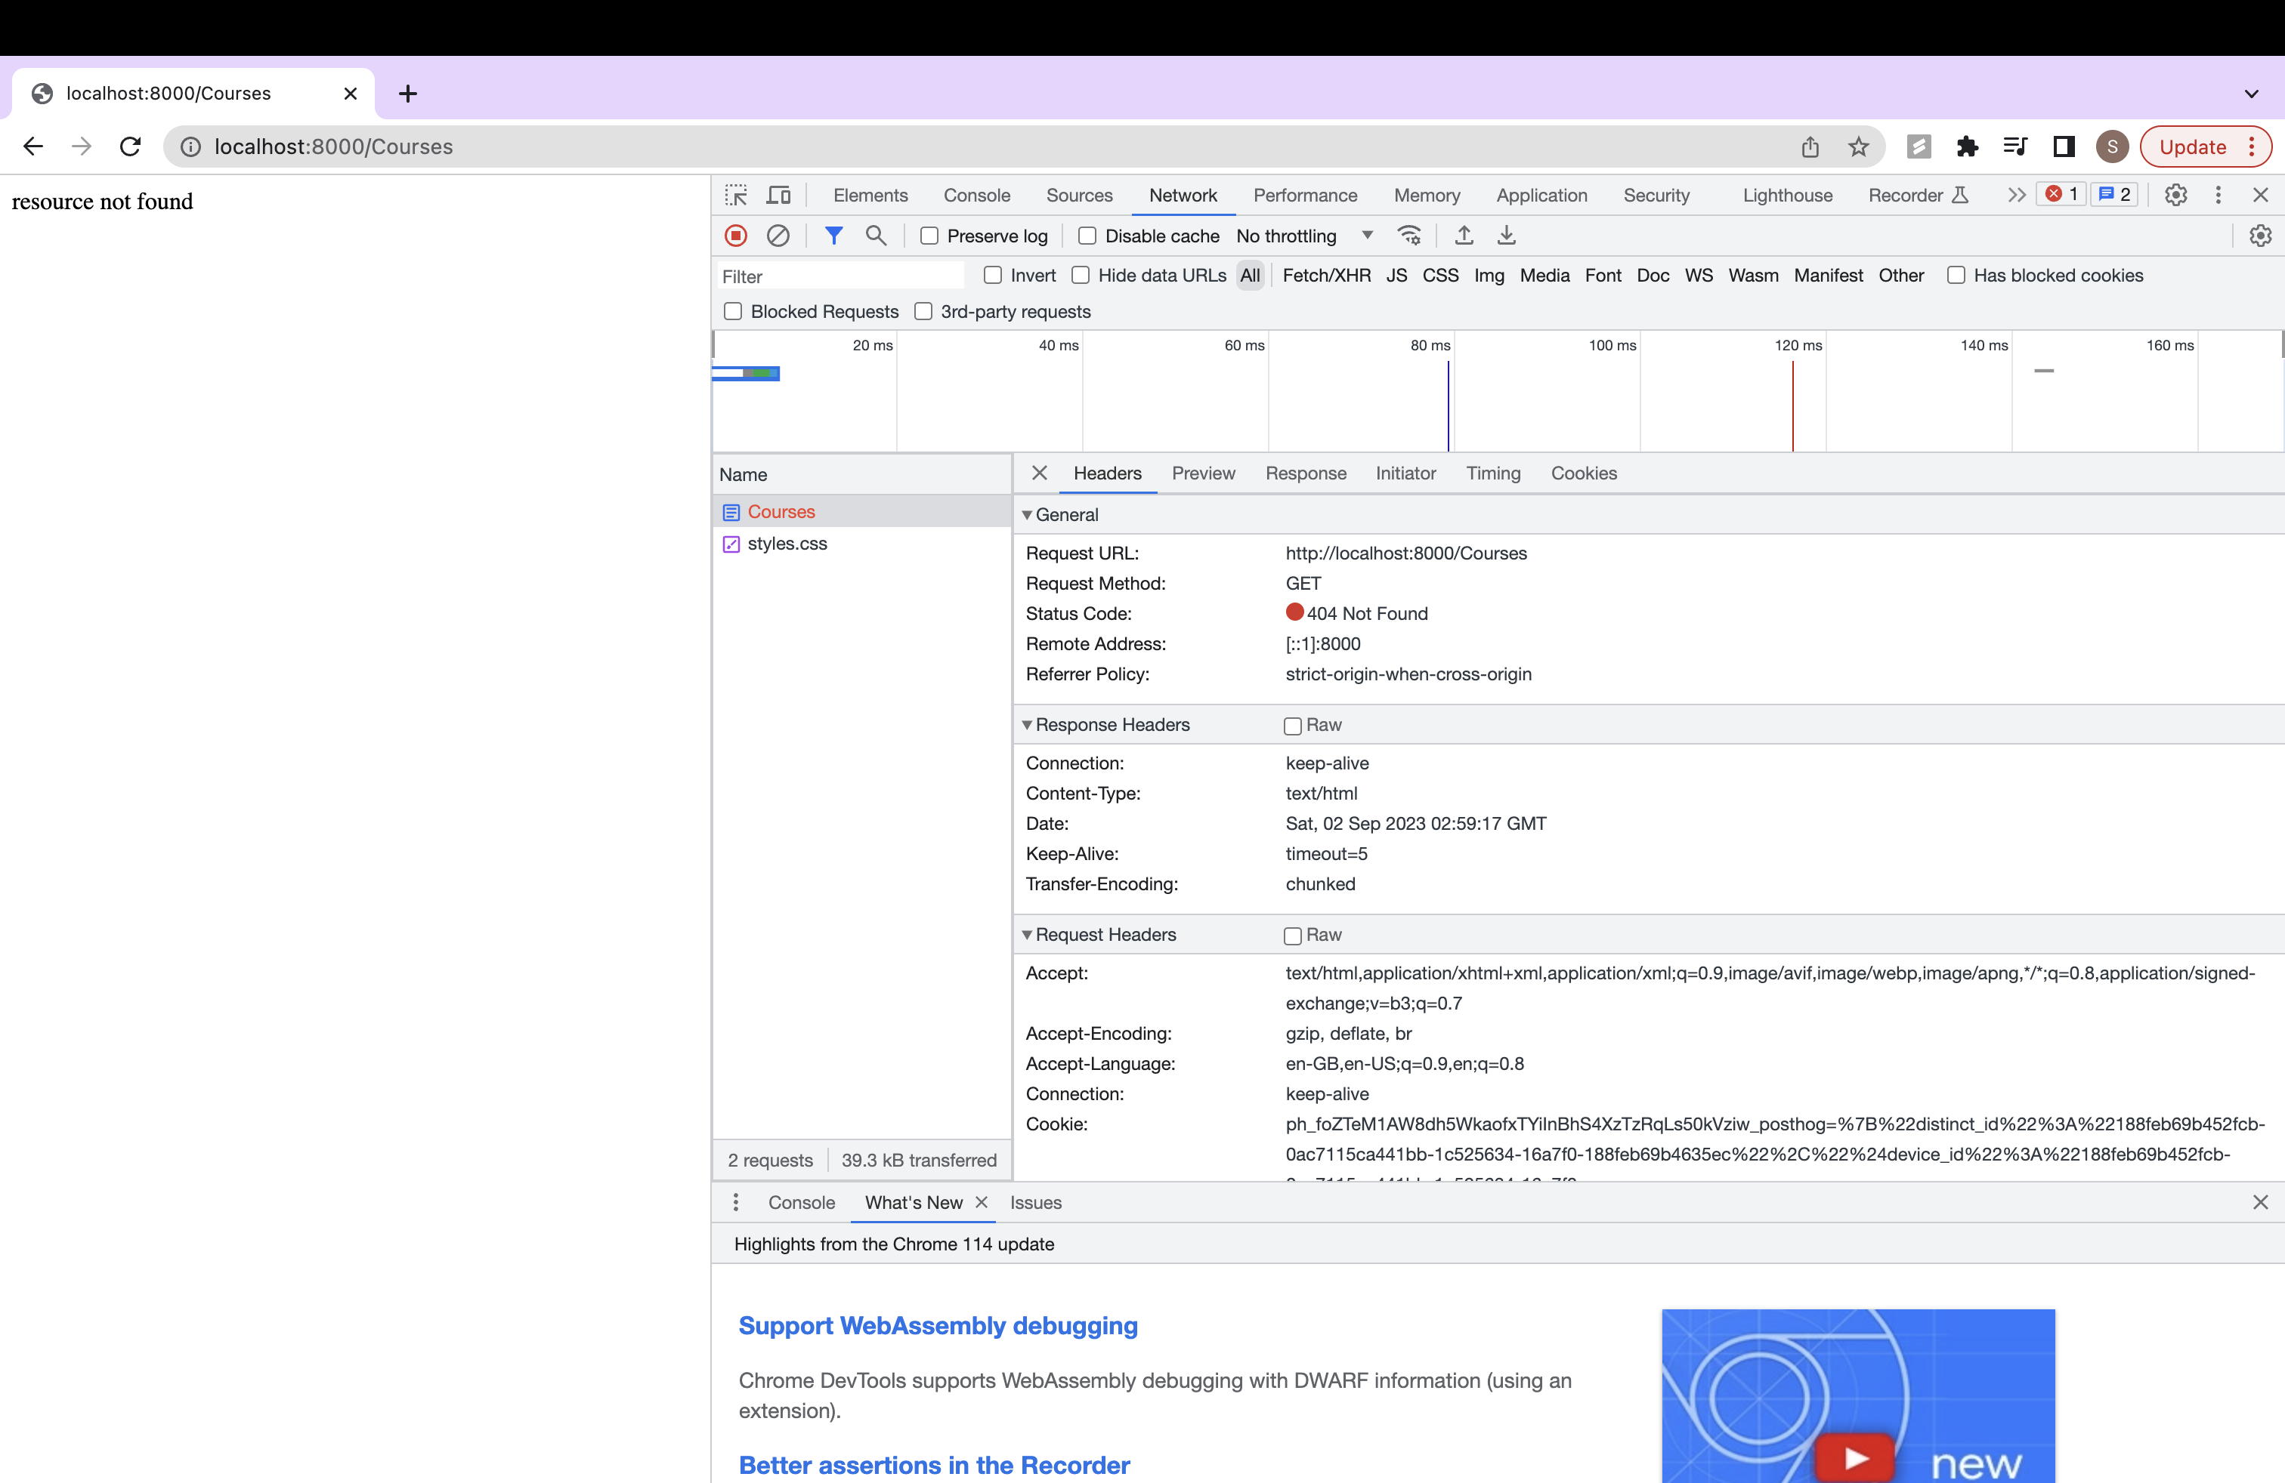

Step6: Reading Data From File and Sending the Data to the Client:

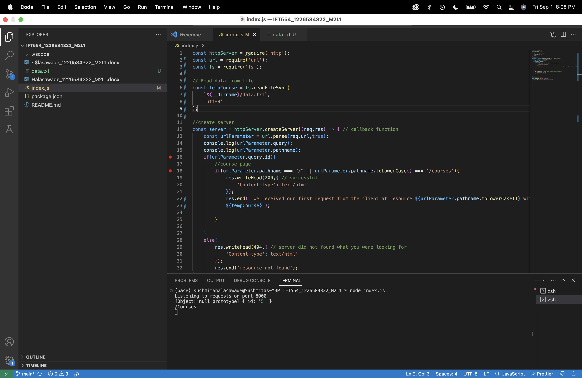

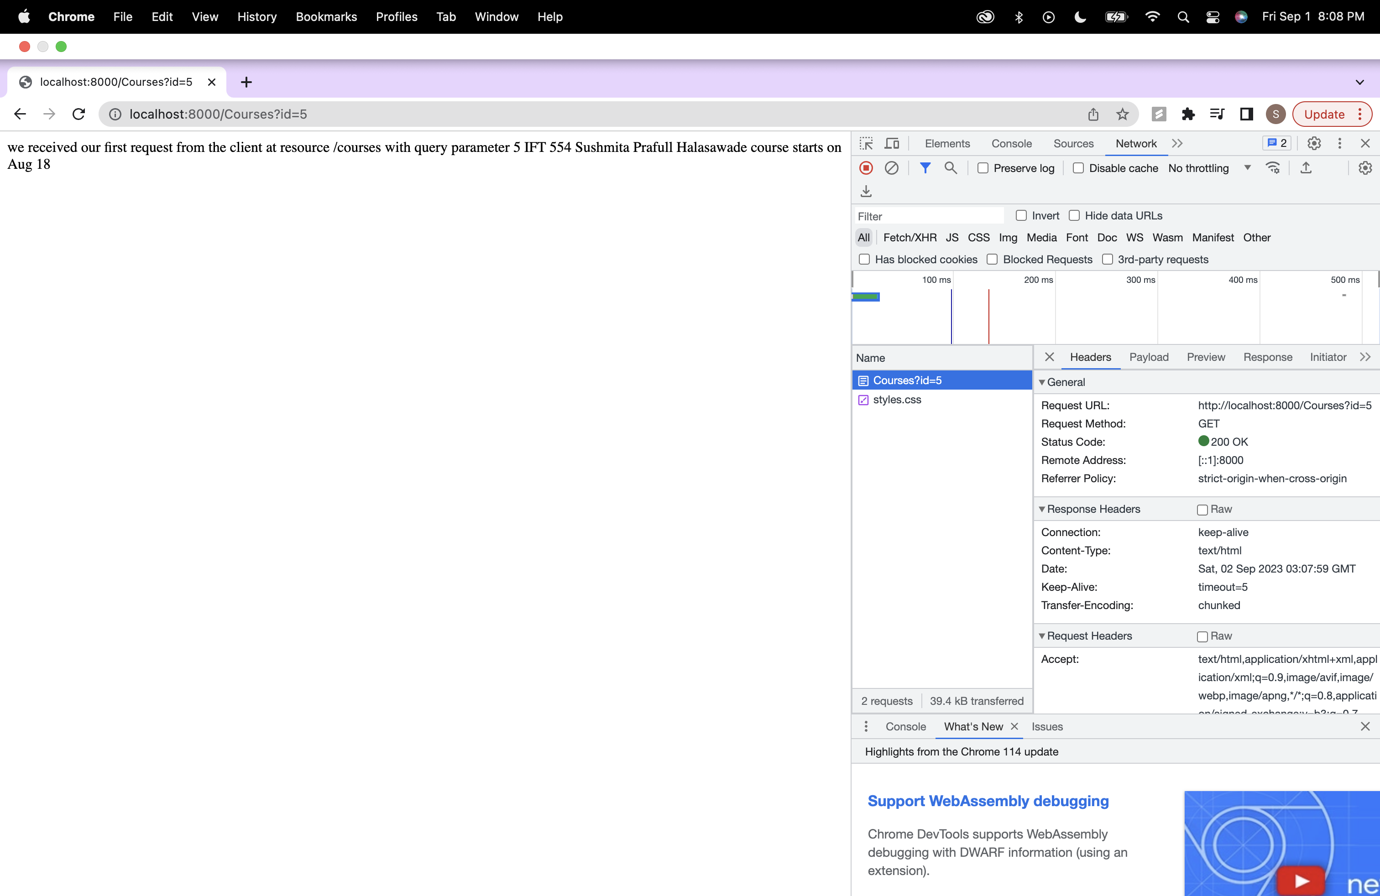

Step 7: Reading JSON data from the file

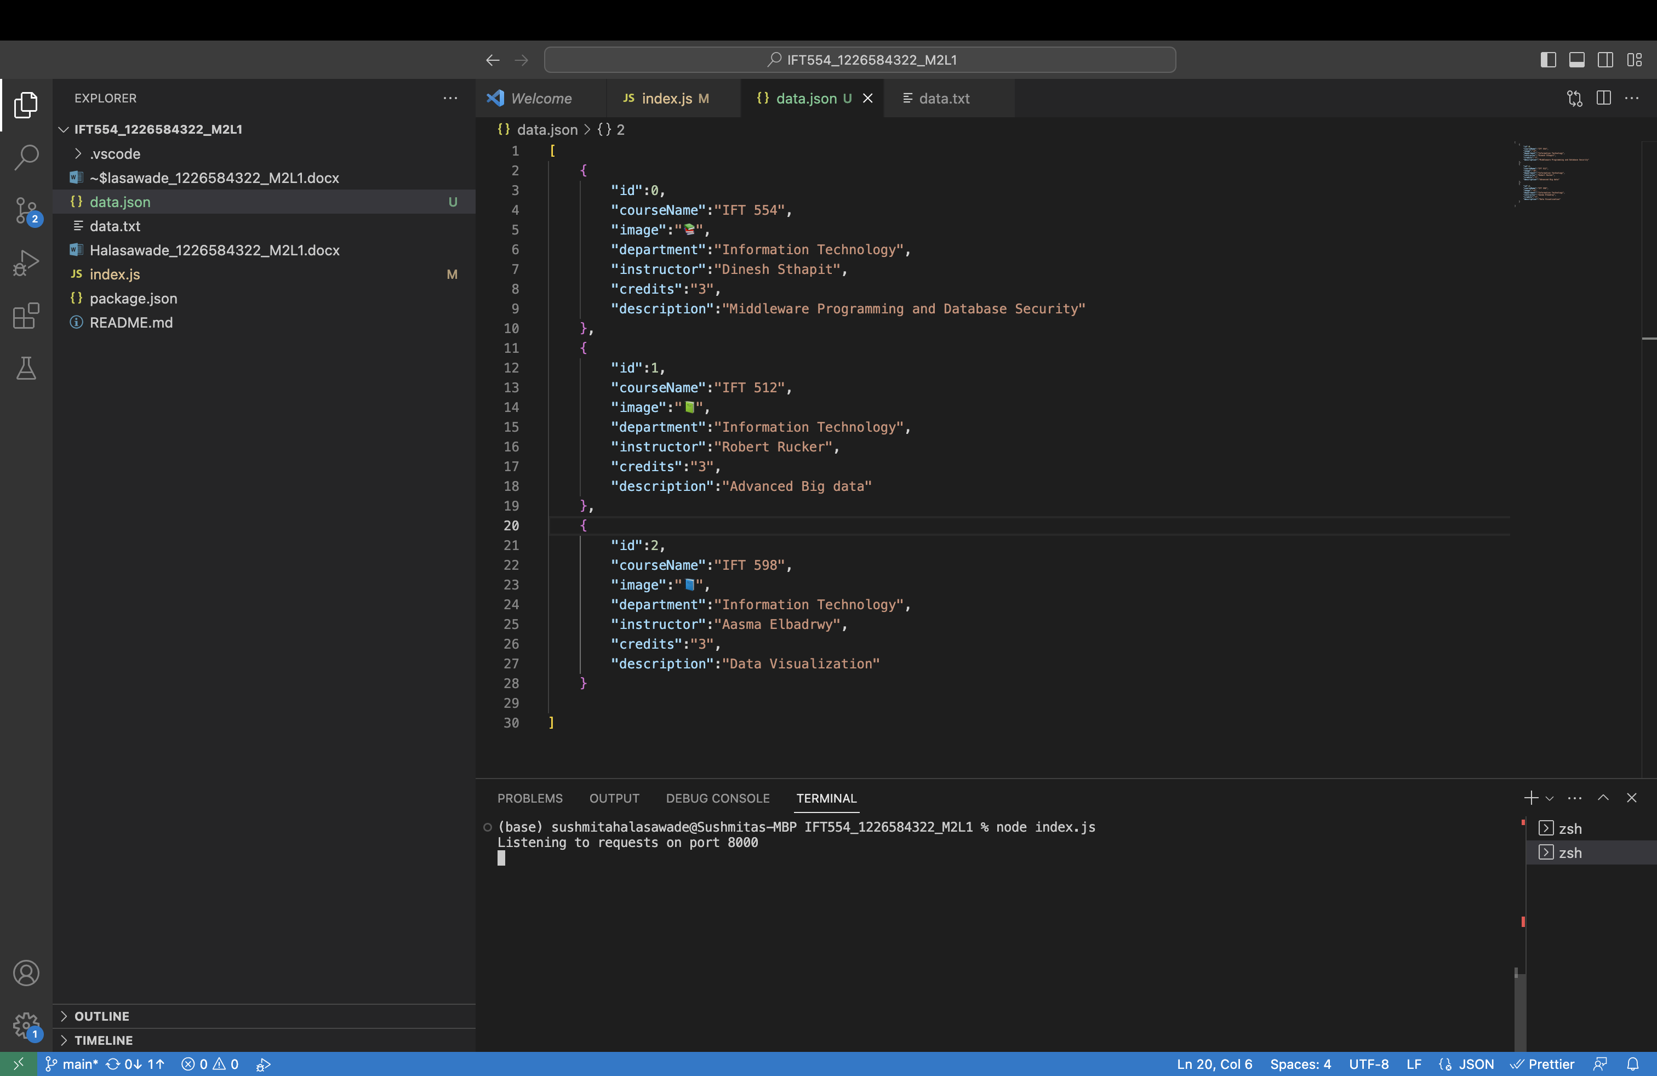

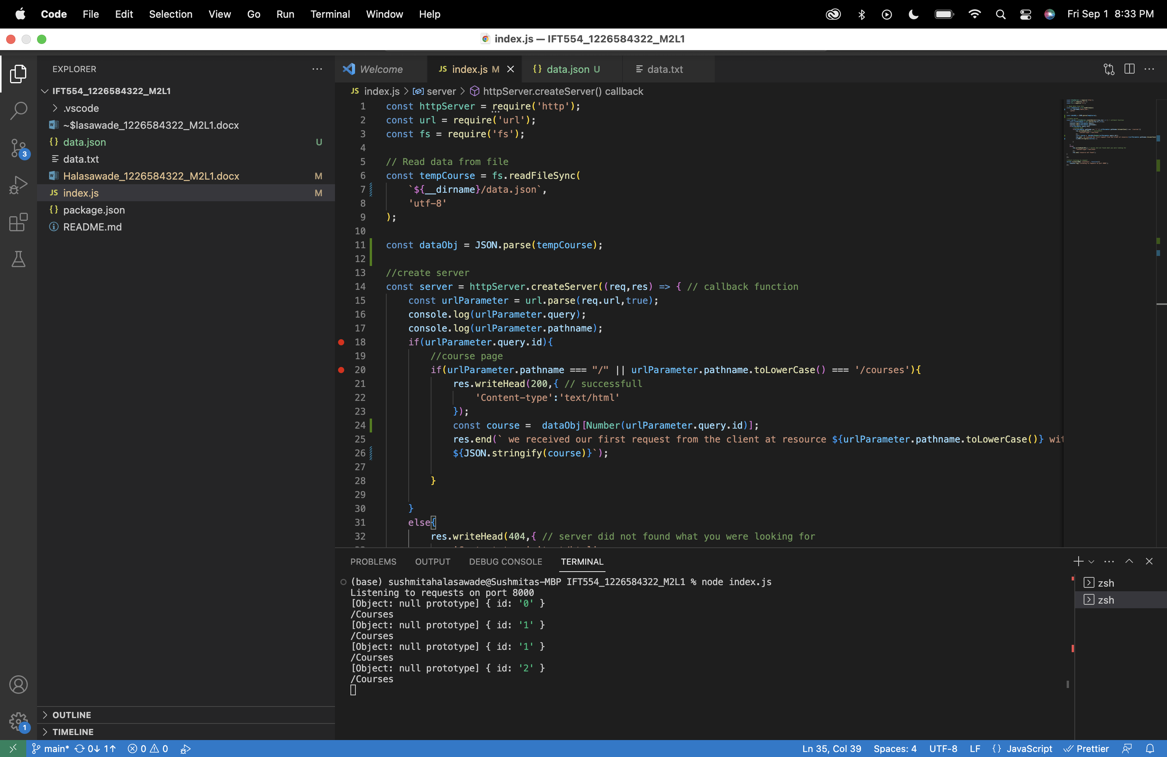

getting JSON data where id = 0:

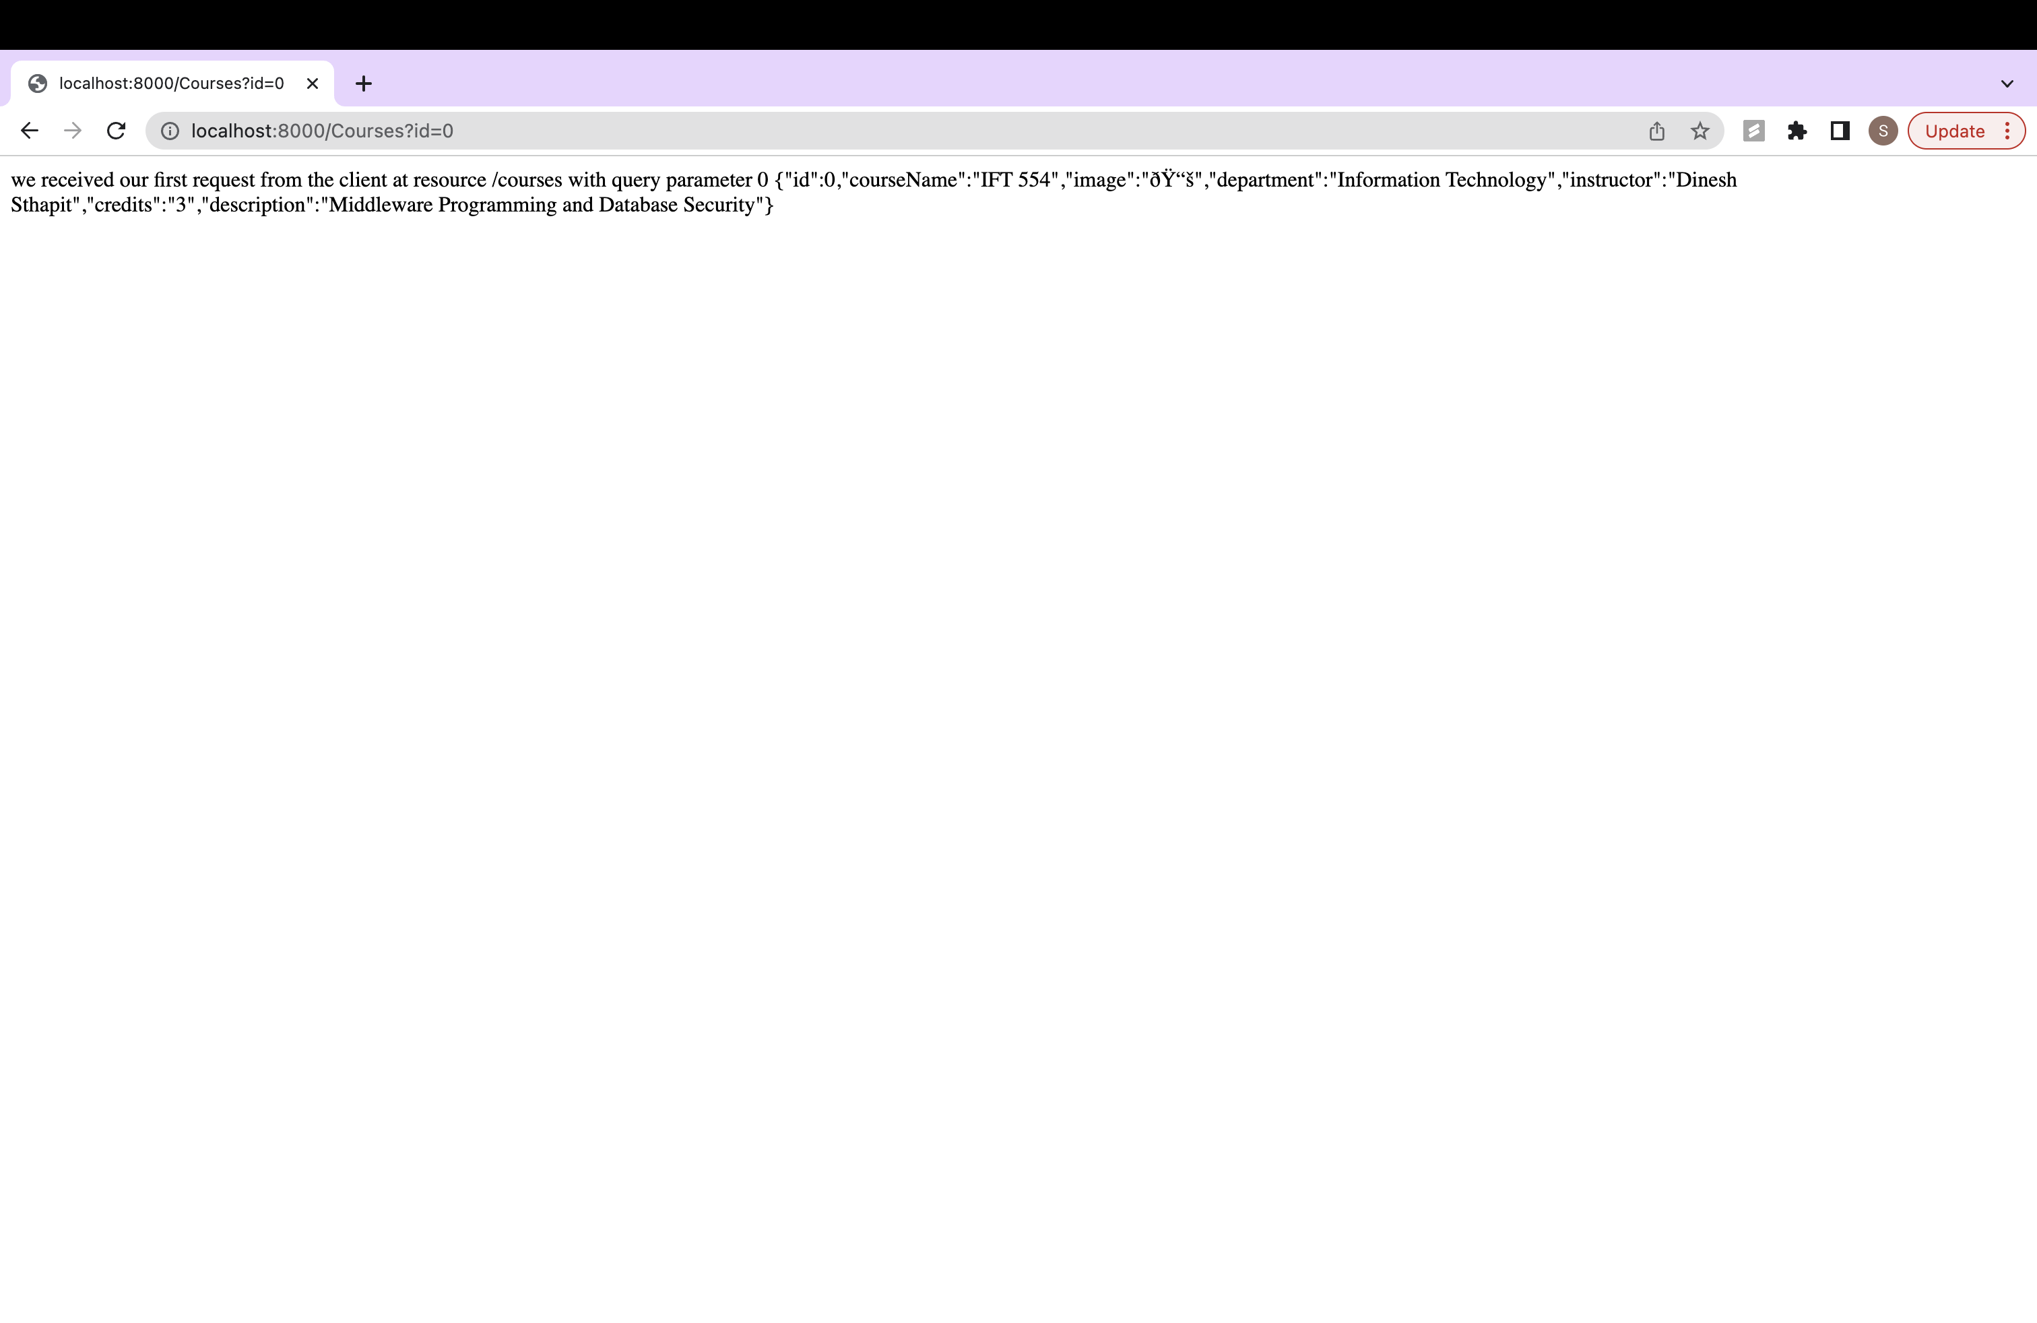

getting JSON data where id = 1:

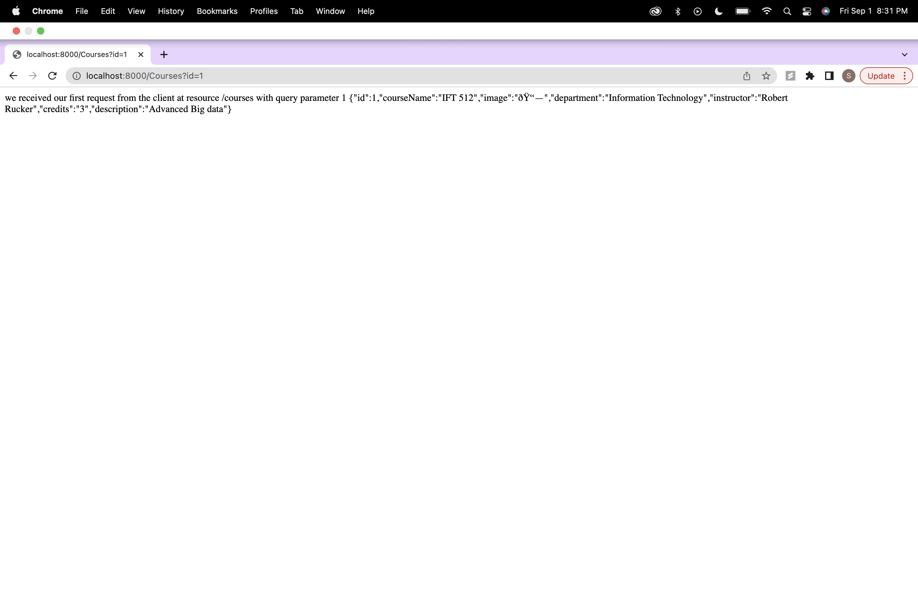

getting JSON data where id = 2:

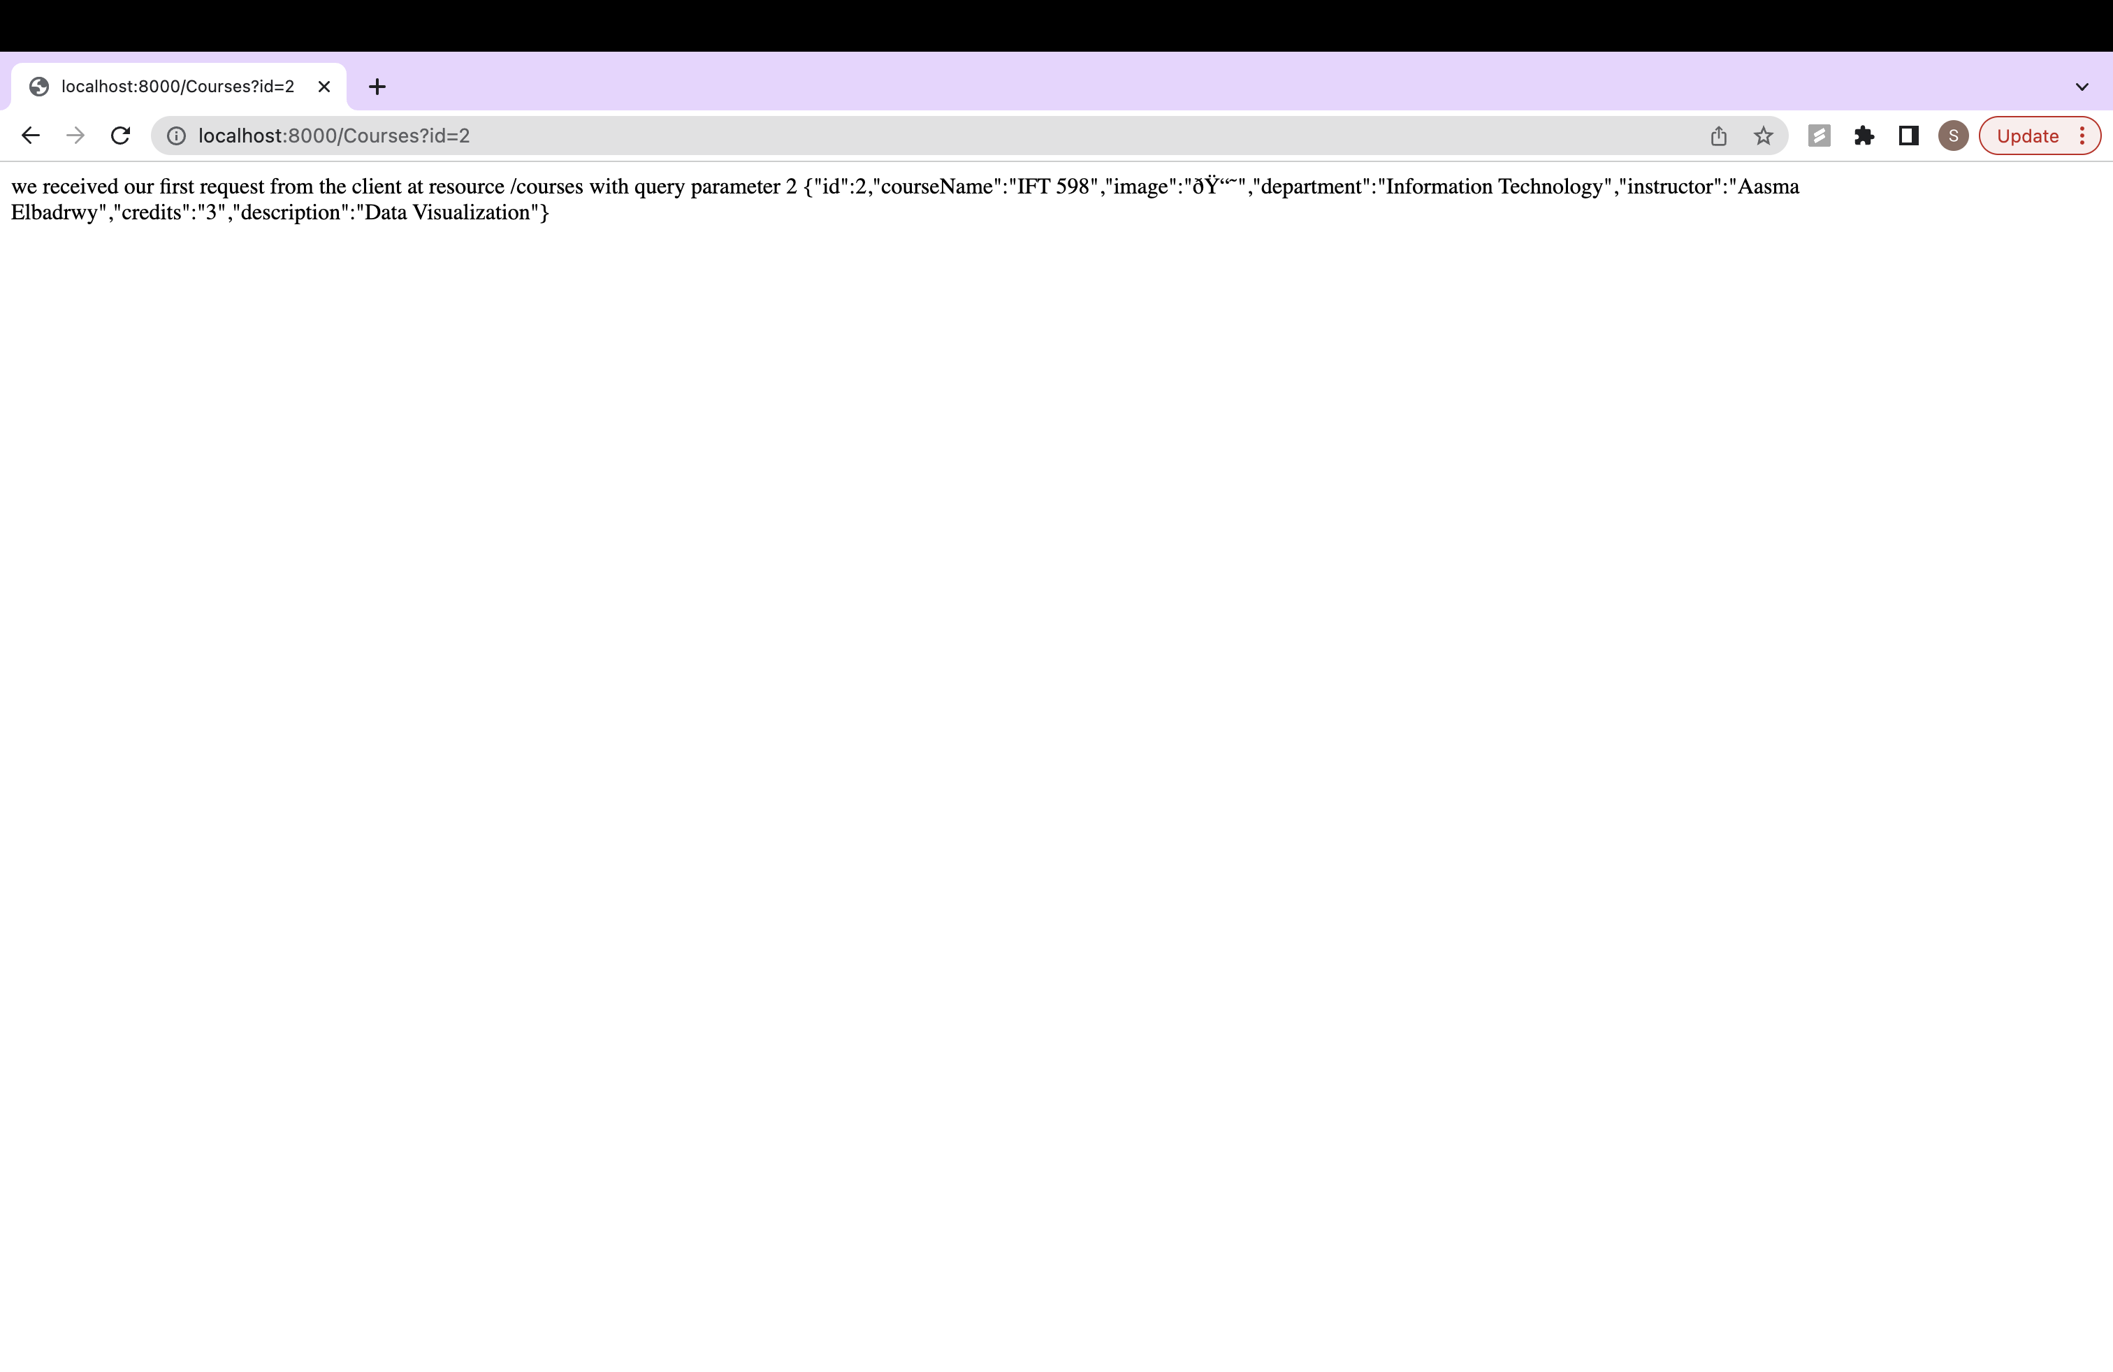

Step 8: Adding a User Interface in HTML

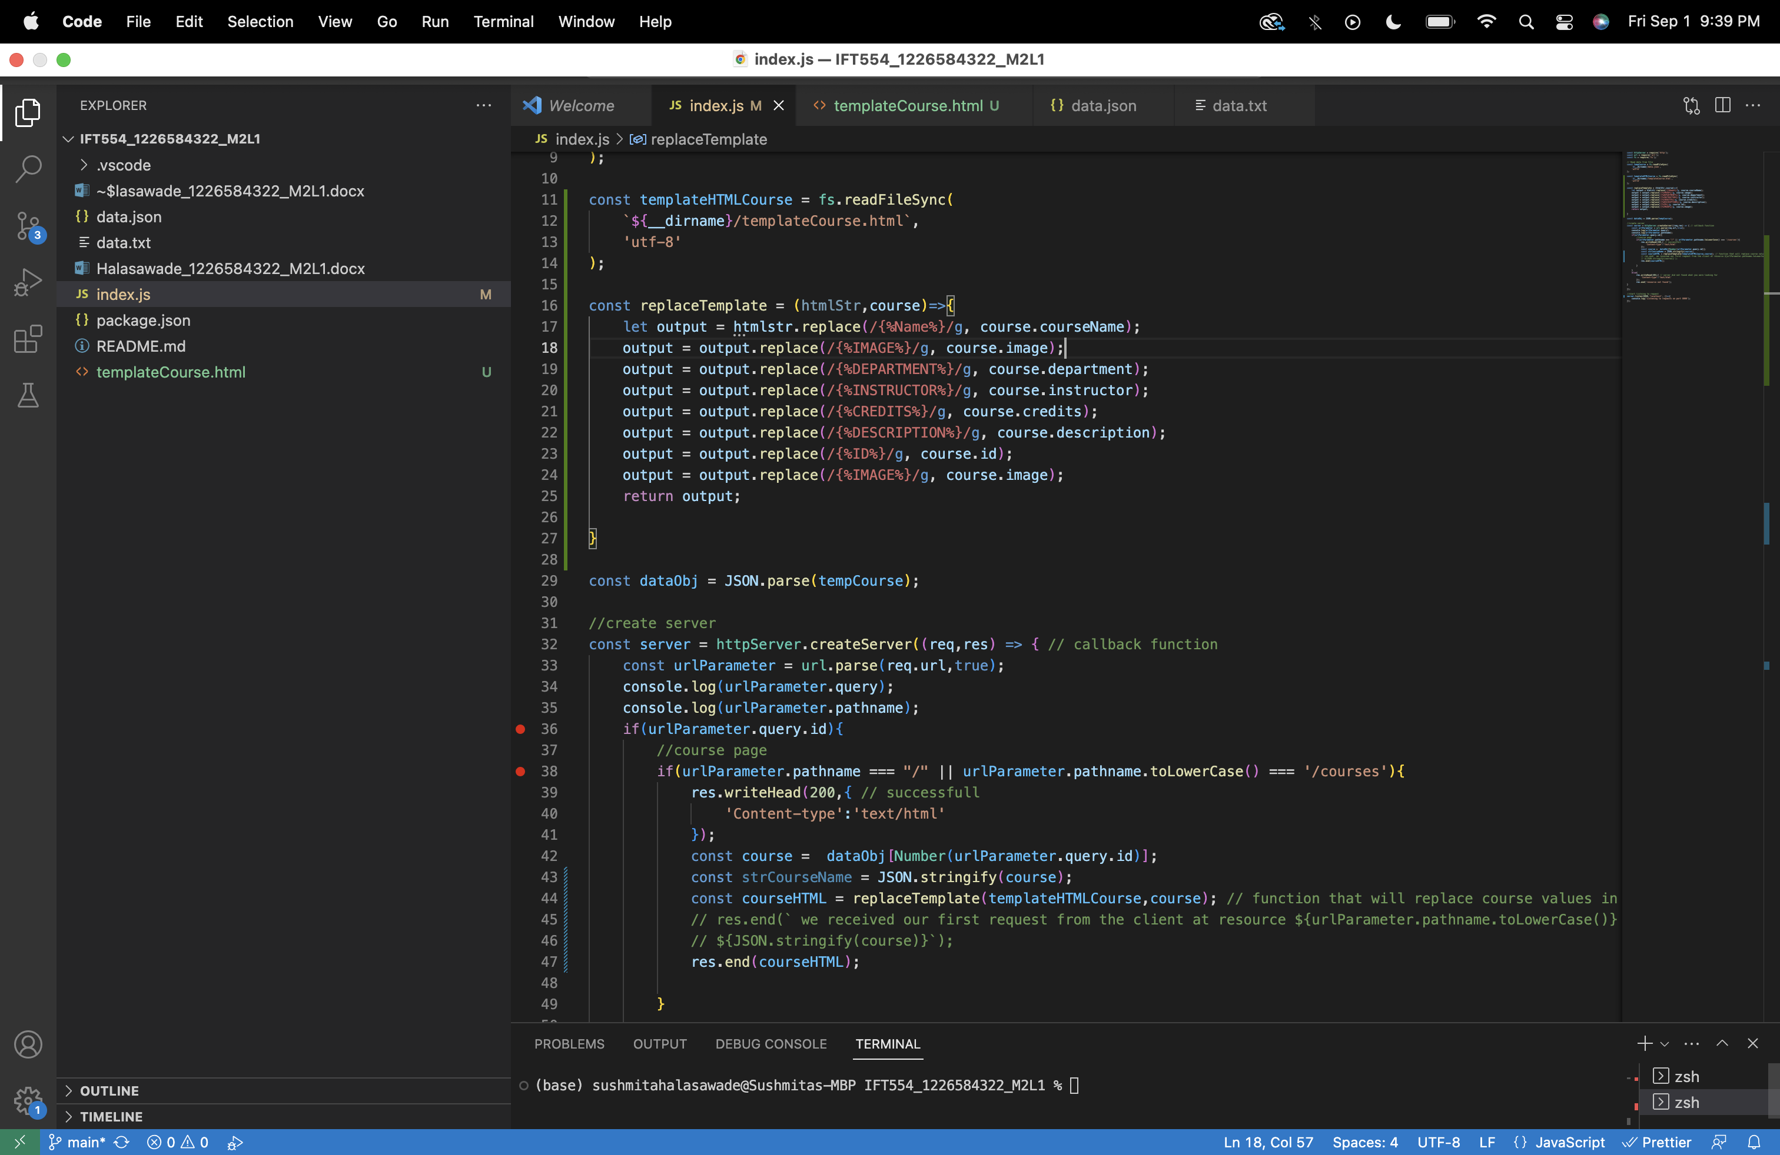

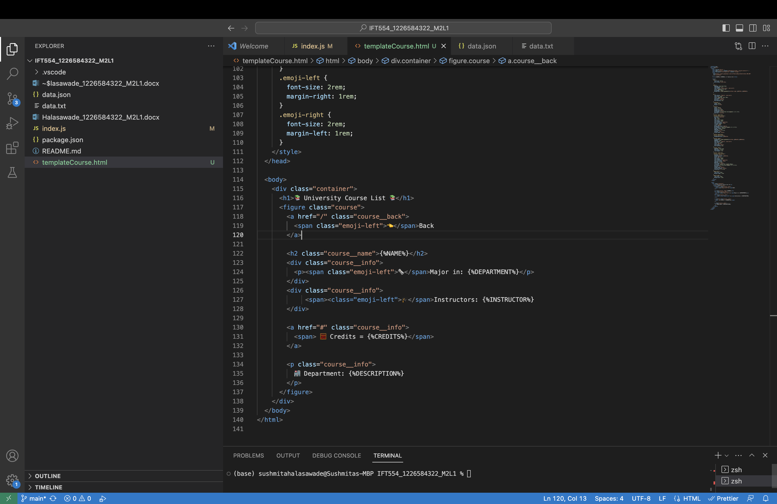

Step9: creating module export (reusable function):

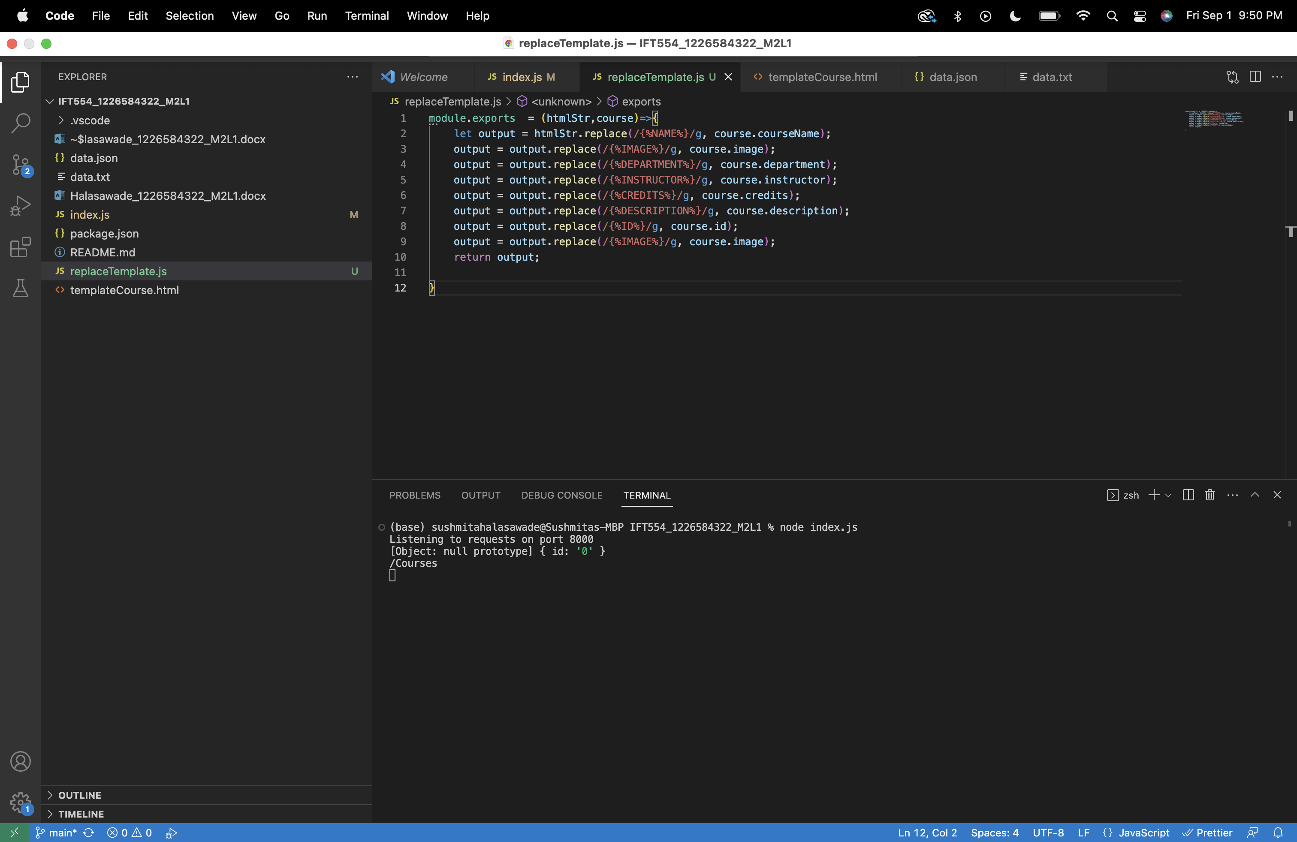

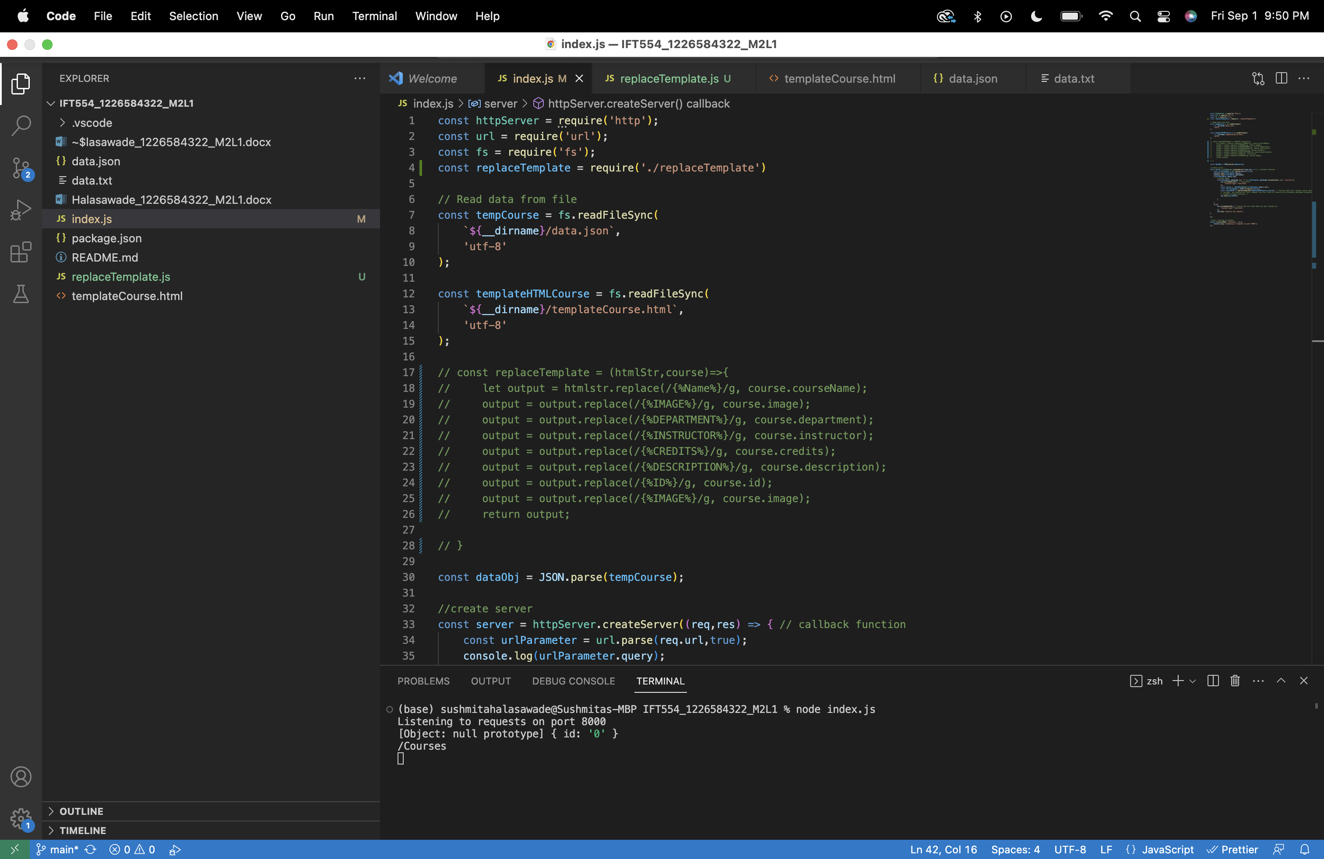

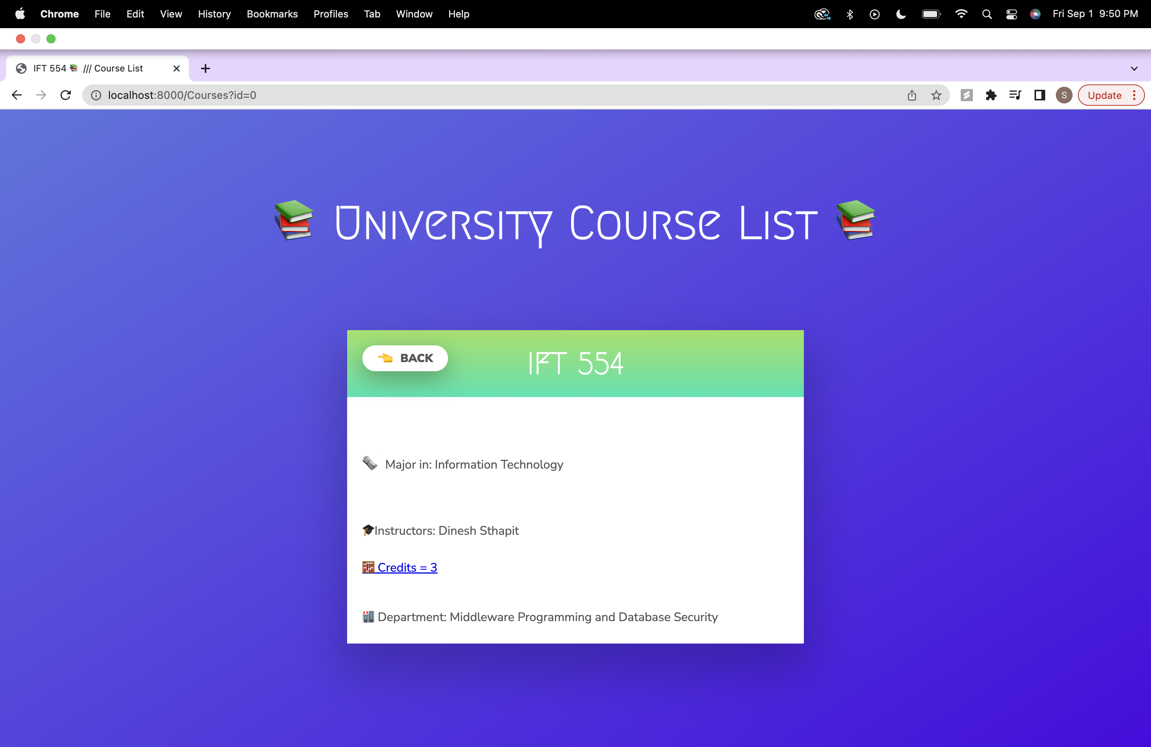

Step10: Object destruction:

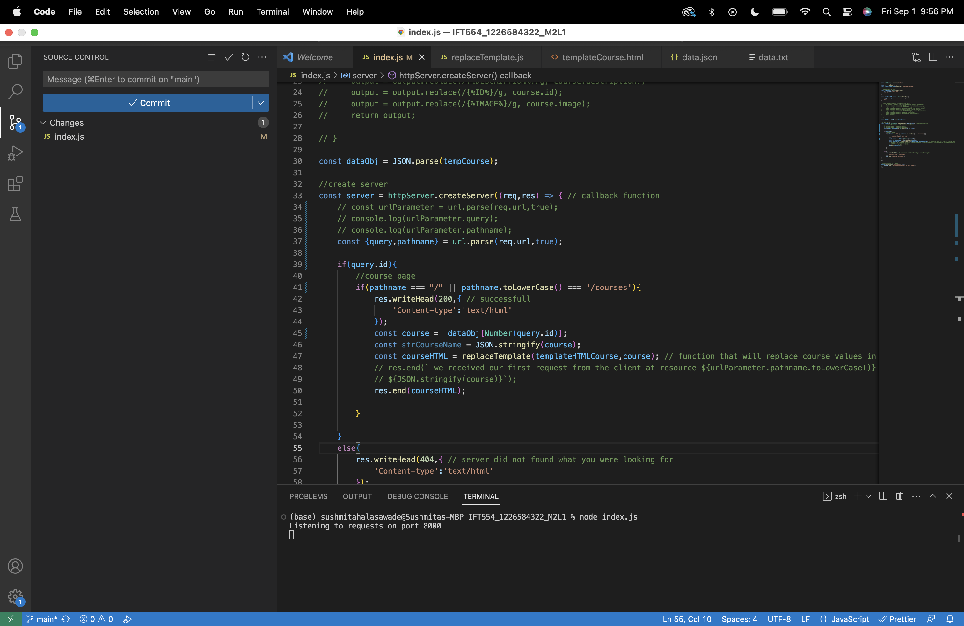

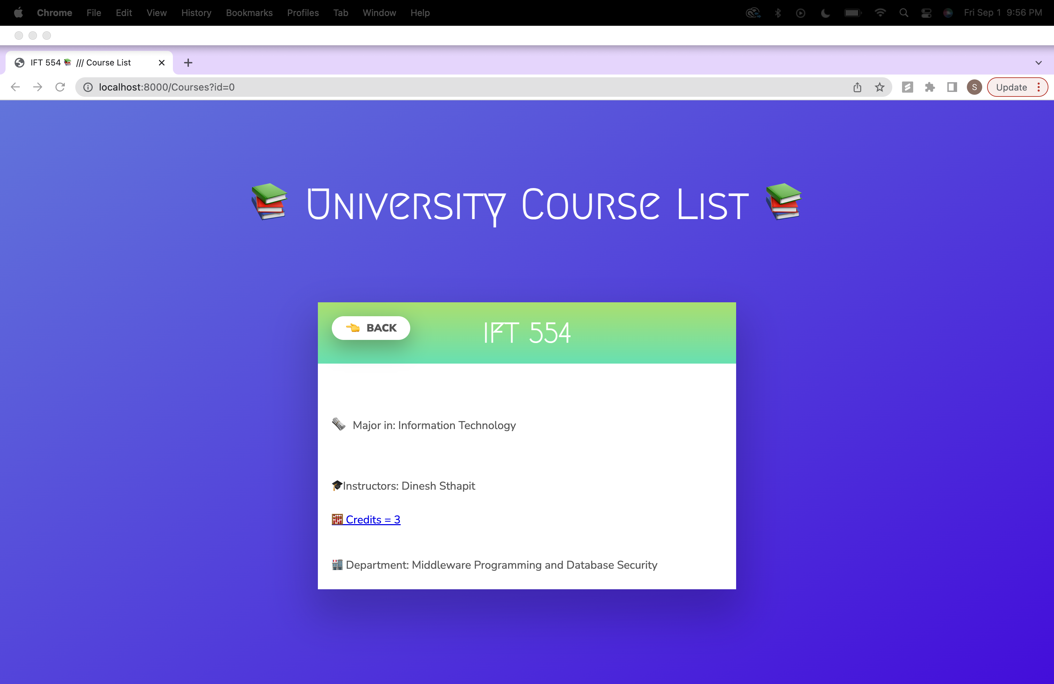

Step 11: Refactoring and re-arranging the folder structure.

